Lab1



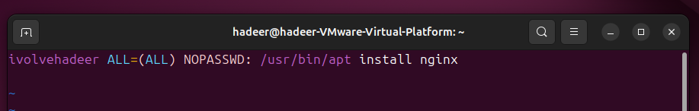

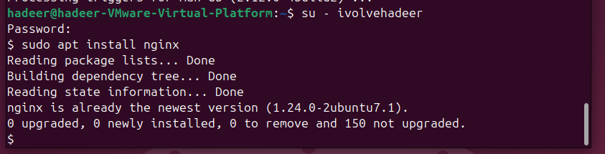

Lab 2

Lab 3



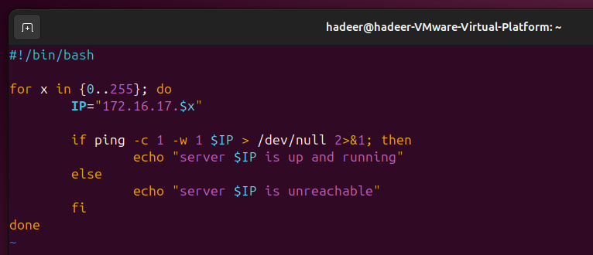

Lab 5